Versions:

Date | Versiune | Autor | Comentarii
20.12.2022 | V2 | Marcu Horea-Radu & Lacatus Arpad-Alex | Second Version(Beta)

Analisys&Design for PostMe

Continut:
- General Presentation

- Theoretical Fundamentals

- IT Technology (which will be implemented)

- Functionalities

- Actors and related access rights

- Use Case Diagrams

- System Architecture

- Design (UML Diagrams)

- Operation Mode (Operation Guide, including screen-shots)

- Portability

1. General Presentation
.
The main purpose of this project is to create a social application, similar to Reddit, in which users will be able to post images or text, be able to upvote or downvote each post, be able to create an account and save content on it, be able to comment on each post, be able to create forums and manage them. In addition, in this application users will be able to use virtual currency in order to download images from the site.

- Theoretical Fundamentals

Regarding theoretical fundamentals, this application is going to be created with the help of three main programming languages, which are javascript, css and html. These are going to help with the frontend of the project, while nodeJS is going to be used to be able to create and connect to a server which deals with the requests and the connection to the database.

- IT Technology

IT Technology refers to the use of computers to create, process, store, retrieve and exchange all kinds of data and information. More precisely, in this project, IT Technology will be used to get the data from the database and to show it on the screen for the user to be able to see. It will also help with storing the posts in the database, so whenever a user creates a post in gets added to the database. The same process is used for forums, which can be created by any user and are stored in the database.

- Functionalities

The main functionalities of this project are the ability of a user to join a forum, create a post or leave a comment on an already existing post. Apart from these functionalities, anyone can create an account and log in with it to be able to interact with the site. Finally, there are some more minor functionalities, regarding the currency which each user has. This means that different people can use their currency or exchange it with other users.
- Actors and related access rights

In this application there are multiple actors which can complete different tasks and have different access rights. The first one, being the most basic one is the user. This actor is the regular person who accesses the site. He is able to see all the different forums, post, like, comment and spend their virtual currency. The next actor is the moderator, who is a user, meaning that he has all the access rights of a regular user, but in addition has some more options. The moderator is able to also reward users, create a new forum, delete posts from forum, manage reported users and warn users. The next actor is the administrator who is one level above the moderator. This is the person who receives requests from users or moderators, updates the website and provides maintenance in case of bugs.
Lastly there is the system, which is the only non-person actor. This is the actor which updates the like or dislike counters, updates the comment section, updates the database and handles the log-ins.

- Use Case Diagrams
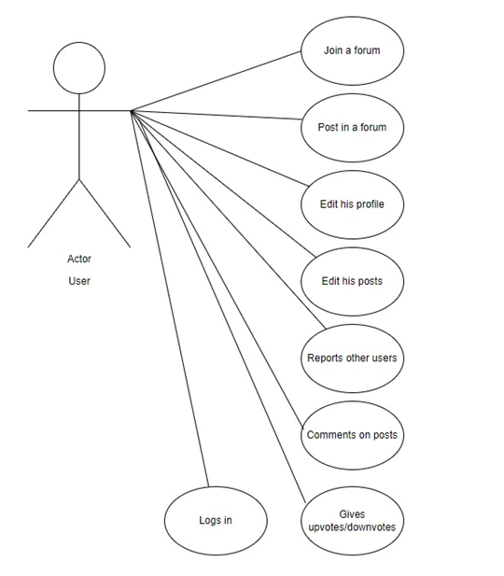

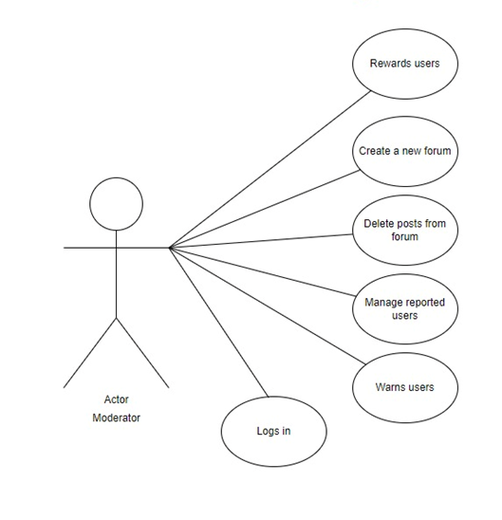

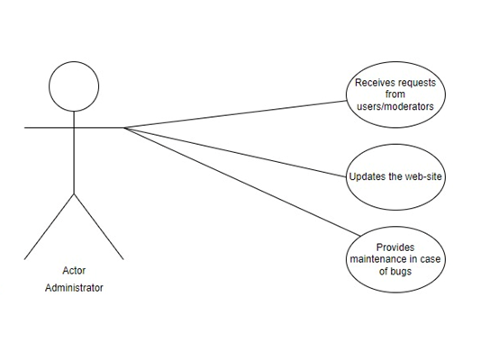
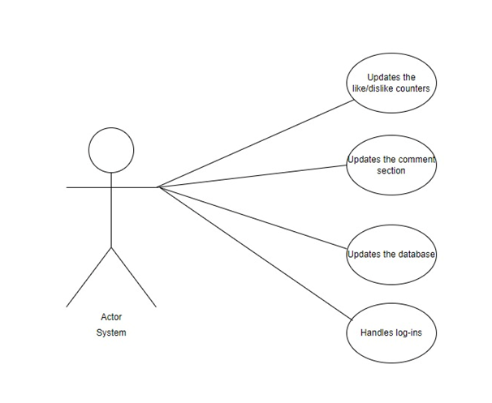
- System Architecture

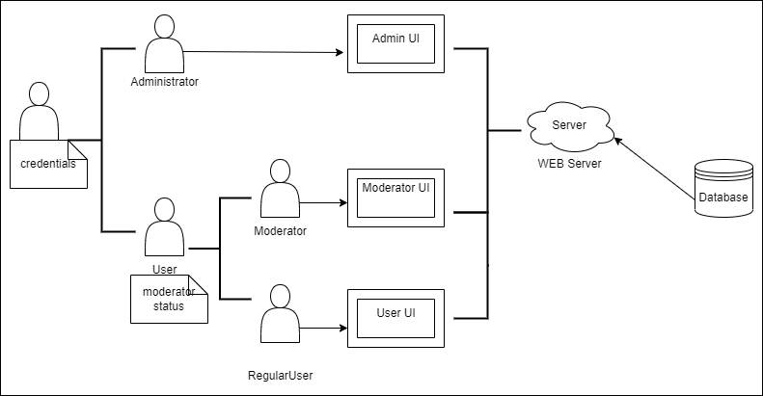
- Design (approx. 12 UML Diagrams!!!)

Class Diagram:
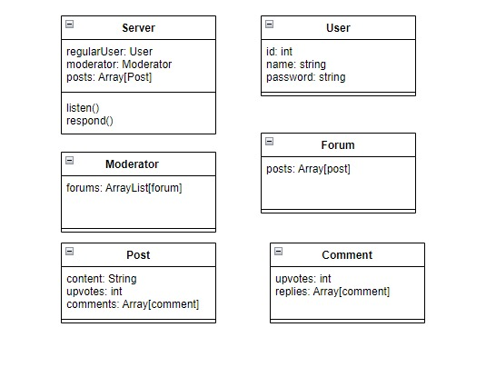

Object Diagram:

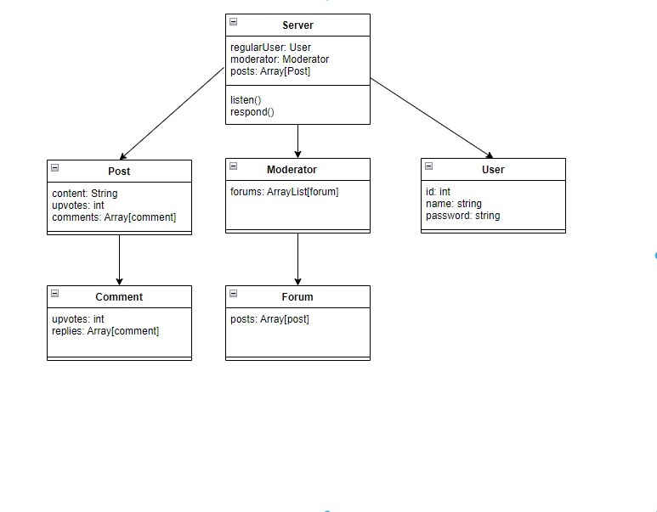

System Architecture Diagram:

Activity Diagram:
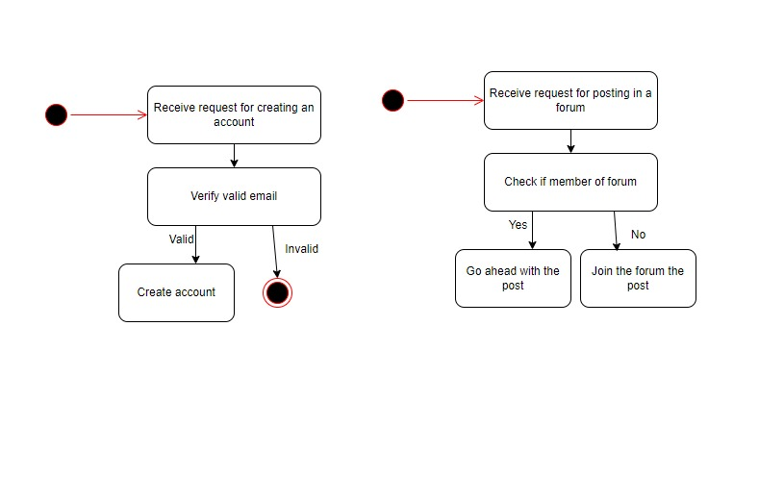

State Transition Diagram:

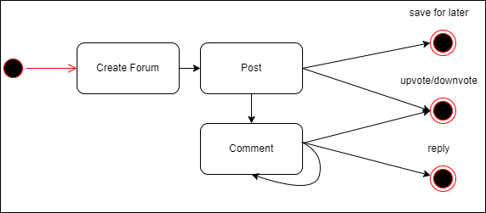

Communication Diagram:

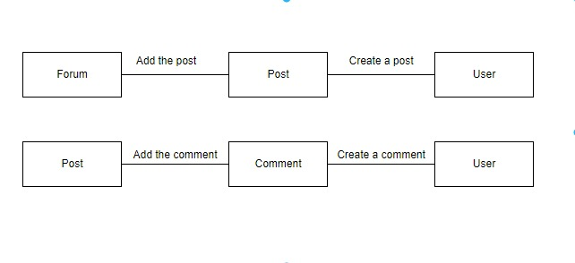

Package Diagram:
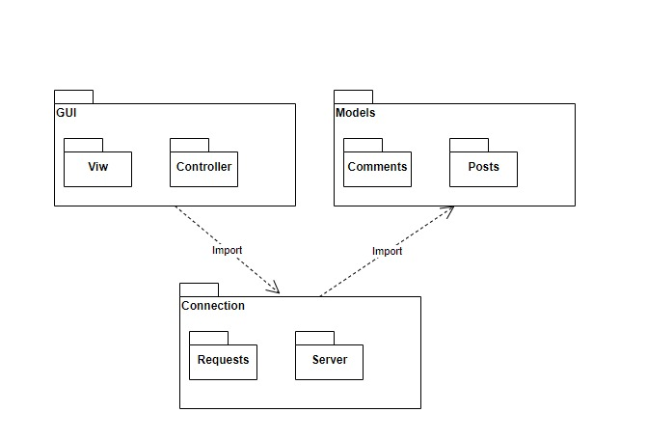
Deployment Diagram:
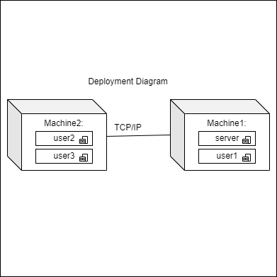

Database Diagram:
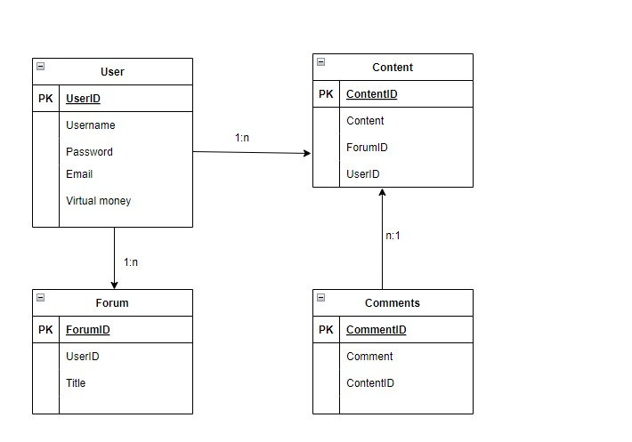

Component Diagram:

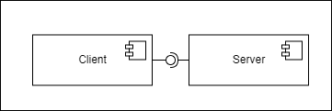

Sequence Diagram:
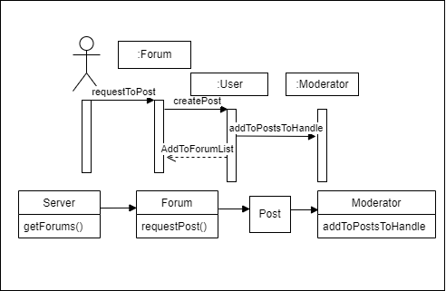

- Operation Mode (Interactivity presentation) + screen shots (UI design)

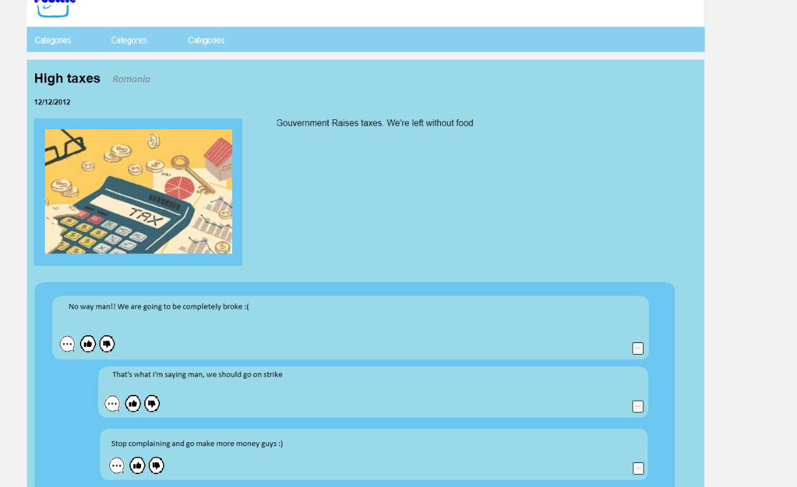

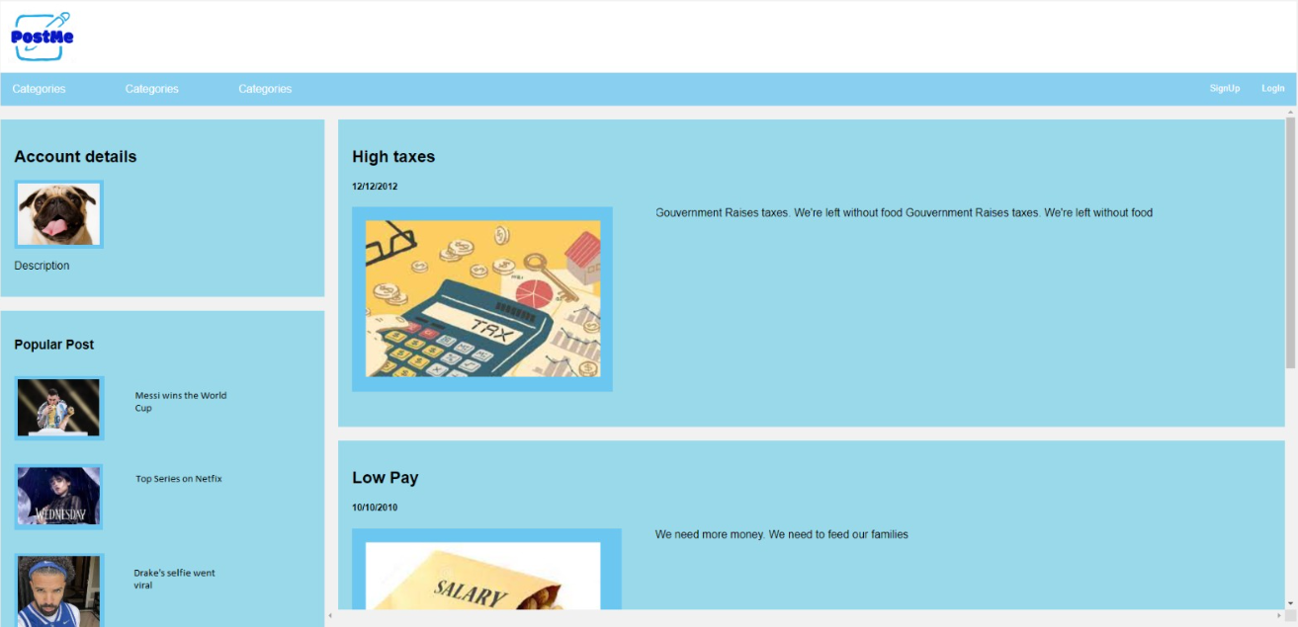

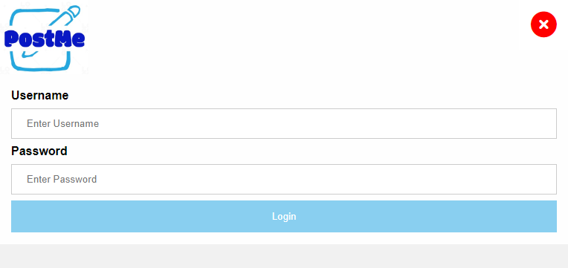

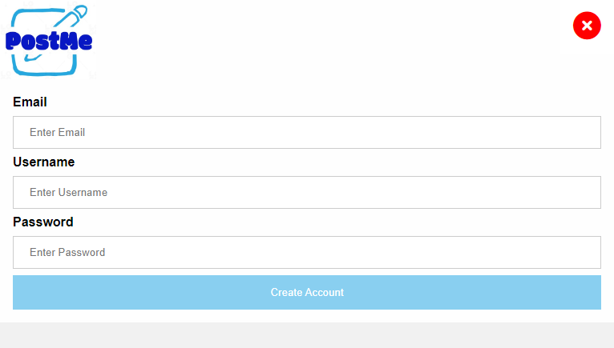
- Portability

This application is going to be a very portable one, which in the future could have an app on the phone to be able to access it from anywhere you go. Until then, users should be able to connect to the application from their phone by using the site just as if they were on a computer.

- Competing software

The main competing software of this application is Reddit, as it has a very similar purpose to it. Both applications are meant to allow users to post and interact with all the different topics that they like. There should not be a problem regarding the similarities of the applications, as in many fields there are very similar applications which all have success despite competing with one another.

